[](http://www.google.hr/imgres?biw=1680&bih=943&tbm=isch&tbnid=JahmJjZQTwA73M:&imgrefurl=http://www.trigon.hr/infodesk/article.asp%3FdocumentId%3D2416&docid=qFNCK_SwKT029M&imgurl=http://www.trigon.hr/upload/infodesk/helpme.jpg&w=500&h=334&ei=GoKeUqLwEKb7yAP9yYGAAQ&zoom=1&ved=1t:3588,r:74,s:0,i:304&iact=rc&page=3&tbnh=183&tbnw=261&start=55&ndsp=33&tx=118&ty=89)

[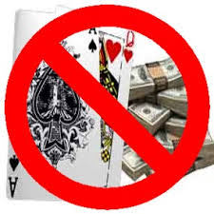](http://www.google.hr/url?sa=i&rct=j&q=&esrc=s&frm=1&source=images&cd=&cad=rja&docid=C2ktcngI73ewZM&tbnid=GyYpNmpHPeVksM:&ved=0CAUQjRw&url=http%3A%2F%2Fwww.southerngaming.com%2F%3Ftag%3Dunlawful-internet-gambling-enforcement-act&ei=M4GeUoHGI4ahtAbA_YGgCA&bvm=bv.57155469,d.bGQ&psig=AFQjCNG8Di-NckWx64x0FMpfMbK1_QoYhQ&ust=1386205854229902)



[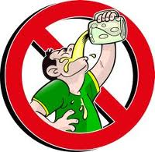](http://www.google.hr/url?sa=i&rct=j&q=&esrc=s&frm=1&source=images&cd=&cad=rja&docid=M0hQHOOJQFbBiM&tbnid=xuMIFNASHPgDHM:&ved=0CAUQjRw&url=http://www.lepotaizdravlje.rs/fashion/vesti/stop-alkoholizmu&ei=xkebUrWPAojIswbx54HwCQ&bvm=bv.57155469,d.bGQ&psig=AFQjCNFMRFwziwa1Afs9OD6EcPRPxrHKkQ&ust=1385994500270306)

[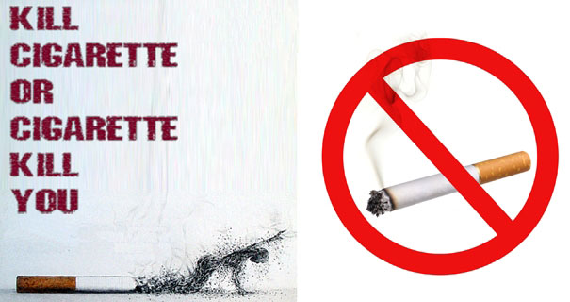](http://www.google.hr/url?sa=i&rct=j&q=&esrc=s&frm=1&source=images&cd=&cad=rja&docid=RVR7h5sfBQuhxM&tbnid=tM5jxMlPErMN9M:&ved=0CAUQjRw&url=http://kladusa.net/portal/velika-kladusa/svjetski-dan-borbe-protiv-pusenja-31-maj-pusenje-svjetski-ubica-br-1/&ei=7lObUrauO4GItQb9y4HgCA&bvm=bv.57155469,d.bGQ&psig=AFQjCNHX3Oyiiu9TYXTCzL8C7StofkOl4A&ust=1385997509437848)